SIMATS ENGINEERING

ASSESSMENT TOOL 1

COURSE NAME: Database Management Systems COURSE CODE: CSA05

COURSE OUTCOME COVERED

CO2: Apply the relational model, relational algebra, SQL query structures, and views to solve database querying and data manipulation problems. (BL3, BL6)

Activity Tool : Analytical Problem Solving (High) Assessment Tool Weightage: 40%

QUESTIONS
Q.N  o | Question | Bloom's Level
1 | Given a set of relations and sample data, write SQL queries to retrieve specific information using joins and subqueries, and explain the logic used.  Bloom’s Level: BL3 – Apply | BL4 – Analyze
2 | Using relational algebra, formulate expressions to solve complex queries such as retrieving records that satisfy multiple conditions across relations.  Bloom’s Level: BL4 – Analyse | BL5 – Evaluate
3 | Given a real-world scenario (e.g., banking or student system), design a relational schema and construct appropriate SQL queries for data retrieval and updates. Bloom’s Level: BL6 – Create | BL6 – Create
4 | Analyse a given SQL query with nested subqueries and predict its output, explaining each step of execution.  Bloom’s Level: BL4 – Analyze | BL6 – Create
5 | Compare different SQL approaches (joins vs subqueries) for solving the same problem and evaluate their efficiency. Bloom’s Level: BL5 – Evaluate | BL4 – Analyze
6 | Design and implement views for a database system to provide restricted data access, and justify their use for security and abstraction.  Bloom’s Level: BL6 – Create | BL5 – Evaluate
7 | Given a database schema, write relational algebra expressions and convert them into equivalent SQL queries, analyzing differences in representation.  Bloom’s Level: BL4 – Analyze | BL4 – Analyze

8 | Optimize a set of inefficient SQL queries by restructuring them using joins, indexing concepts, or views, and evaluate performance improvements.  Bloom’s Level: BL5 – Evaluate | BL5 – Evaluate
9 | Develop a complex SQL query involving grouping, aggregation, and nested queries to solve a real-world problem.  Bloom’s Level: BL6 – Create | BL6 – Create
10 | Given multiple relations, analyze the query requirements and decide whether to use views, joins, or subqueries, justifying your choice with reasoning.  Bloom’s Level: BL5 – Evaluate | BL5 – Evaluate

Code of Conduct:

I M.Devi Srilatha (192525236) certify that this submission is my original work and that I have adhered to the guidelines specified for this assessment. I understand that any violation of academic integrity rules will result in disciplinary action.
Signature of the student:

RUBRICS FOR CALCULATION:

Criteria | Level 4 (Exemplary) | Level 3 (Proficient) | Level 2 (Developing) | Level 1 (Beginning  )
Problem Understandin g | Clearly interprets problem, identifies all parameters and requirements accurately | Understand s problem with minor gaps | Partial understandin g; misses key elements | Misinterpret s or unable to understand problem
Method Selection | Selects most appropriate method/formul a with strong justification | Selects correct method with minor errors | Inappropriate or partially correct method | Unable to select method
Solution Process | Logical, systematic steps with correct approach throughout | Mostly correct steps with minor mistakes | Disorganized steps; multiple errors | No clear process
Accuracy of Calculation | All calculations accurate; | Minor calculation errors | Frequent errors; incorrect final answer | No valid calculations

correct final
answer
Interpretation of Results | Clearly interprets results with units and engineering relevance | Basic interpretatio n with minor omissions | Limited or unclear interpretation | No interpretatio n

- SQL Joins and Subqueries (BL3 – Apply)

Aim
To write SQL queries using Joins and Subqueries to retrieve information from multiple tables.
PART A – JOINS
1 .Display Student Name and Course Name.

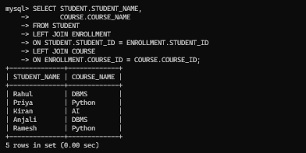

Logic
- STUDENT and ENROLLMENT are joined using STUDENT_ID.
- ENROLLMENT and COURSE are joined using COURSE_ID.
- Displays the student's enrolled course
2 . Display Student Name, Course Name and Marks.
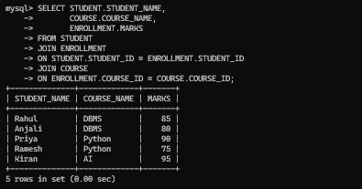

Logic
- Retrieves student details.
- Retrieves course details.
- Retrieves marks from enrollment

3 . Display all students even if they are not enrolled.

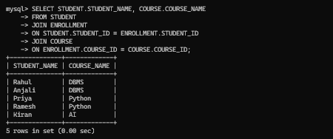

Logic
- LEFT JOIN shows every student.
- If a student has no course, NULL is displayed

PART B – SUBQUERIES

4. Find the student with the highest marks

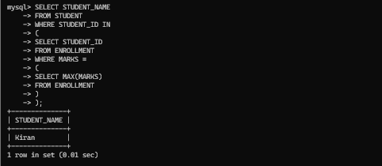

Logic
- MAX() finds highest marks.
- Inner query returns highest mark.
- Middle query finds student ID.
- Outer query displays student name.

5. Display students who scored above average.
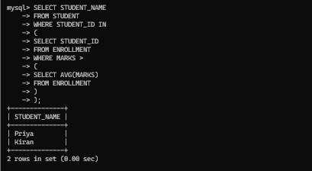

Logic
- AVG() calculates average marks.
- Subquery finds students above average.
- Main query displays their names.
6. Display courses taken by Rahul.

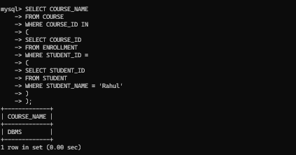

Logic
- Finds Rahul's Student ID.
- Finds his Course ID.
- Displays the course name.

- Relational Algebra Operators Table

Notation | Operator Name | Explanation | Example
σ (Sigma) | Selection | Selects rows that satisfy a given condition. | σ DEPARTMENT='CSE'(STUDENT)
π (Pi) | Projection | Selects specific columns from a relation. | π STUDENT_NAME(STUDENT)
∪ | Union | Combines tuples from two compatible relations and removes duplicates. | STUDENT_CSE ∪ STUDENT_ECE
− | Set Difference | Returns tuples present in the first relation but not in the second. | STUDENT − PASSED_STUDENT
∩ | Intersection | Returns only the common tuples from two relations. | CSE_STUDENT ∩ HOSTELLER
× | Cartesian Product | Combines every tuple of one relation with every tuple of another relation. | STUDENT × COURSE
⋈ | Join | Combines related tuples from two or more relations based on a common attribute. | STUDENT ⋈ ENROLLMENT
⨝θ | Theta Join | Joins two relations using any comparison operator (=, <, >, <=, >=, ≠). | STUDENT ⨝ STUDENT.STUDENT_ID=ENROLLMENT.STUDENT_ID ENROLLMENT
⋈ (Natural Join) | Natural Join | Joins relations automatically using columns with the same name. | STUDENT ⋈ ENROLLMENT
⟕ | Left Outer Join | Returns all tuples from the left relation and matching tuples from the right relation. | STUDENT ⟕ ENROLLMENT
⟖ | Right Outer Join | Returns all tuples from the right relation and matching tuples from the left relation. | STUDENT ⟖ ENROLLMENT
⟗ | Full Outer Join | Returns all tuples from both relations, matching where possible. | STUDENT ⟗ ENROLLMENT
÷ | Division | Returns values associated with all values in another relation. | ENROLLMENT ÷ COURSE
ρ (Rho) | Rename | Renames a relation or its attributes. | ρ S(STUDENT)
← | Assignment | Assigns the result of a relational algebra expression to a temporary relation. | T ← σ DEPARTMENT='CSE'(STUDENT)

Common Relational Algebra Queries

Query | Relational Algebra Expression
Display all students | STUDENT
Display only student names | π STUDENT_NAME(STUDENT)
Display CSE students | σ DEPARTMENT='CSE'(STUDENT)
Display students with marks > 80 | π STUDENT_NAME(σ MARKS>80(STUDENT ⋈ ENROLLMENT))
Display Student Name and Course Name | π STUDENT_NAME, COURSE_NAME(STUDENT ⋈ ENROLLMENT ⋈ COURSE)
Display students enrolled in DBMS | π STUDENT_NAME(σ COURSE_NAME='DBMS'(STUDENT ⋈ ENROLLMENT ⋈ COURSE))
Display CSE students with marks > 80 | π STUDENT_NAME(σ DEPARTMENT='CSE' ∧ MARKS>80(STUDENT ⋈ ENROLLMENT))
Display faculty handling AI | π FACULTY(σ COURSE_NAME='AI'(COURSE))
Display Student Name, Course Name and Marks | π STUDENT_NAME, COURSE_NAME, MARKS(STUDENT ⋈ ENROLLMENT ⋈ COURSE)

- Design a Relational Schema and Construct SQL Queries

Aim
To design a relational schema for a Student Management System and write SQL queries for data retrieval and updates.
1 . Display all students
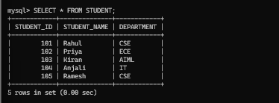

2 . Display students from the CSE department

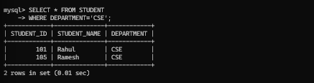

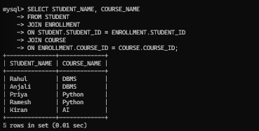
3 . Display student names and course names

4 . Display students scoring above 80

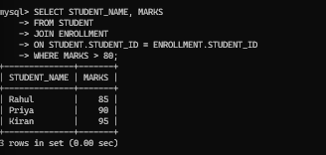

5 . Update Rahul's Marks

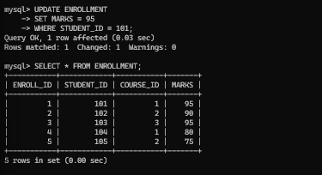

6 . Update Priya's Department

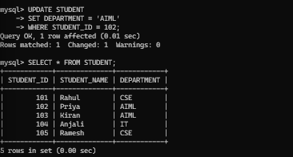

7 . Delete Student Ramesh

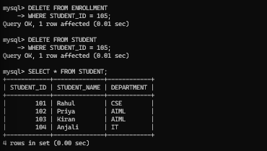

8. Display Student Details with Course and Marks

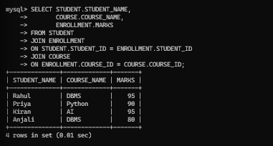

- Analyse a given SQL query with nested subqueries and predict its output.

Aim
To analyze SQL queries containing nested subqueries, predict their output, and understand the execution process.
1 . Display the student who scored the highest marks.

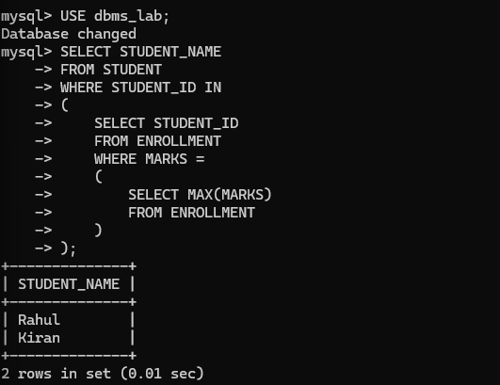

2 . Display students who scored above the average marks.

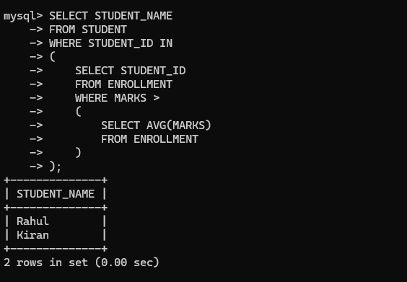

3 . Display the course taken by Rahul

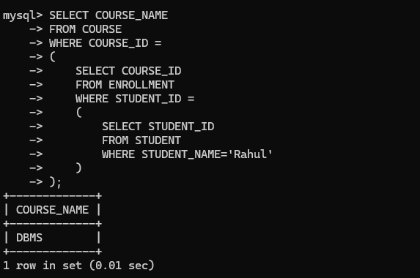

4 . Display students who belong to the same department as Rahul.

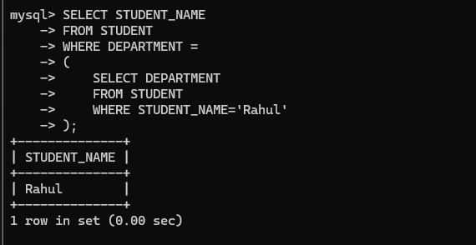

5 . Display students who belong to the same department as Rahul.

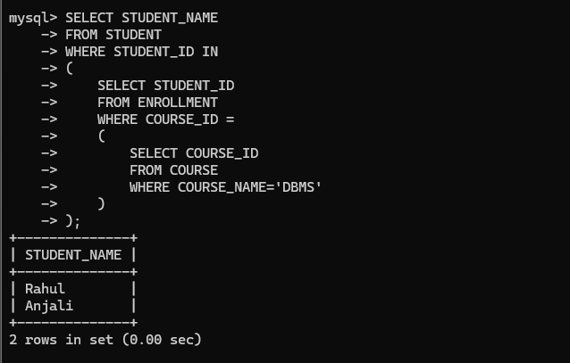

- Experiment: Compare Different SQL Approaches (Joins vs Subqueries)

Aim
To compare SQL queries using Joins and Subqueries for solving the same problem and evaluate their efficiency.
1 . Display Student Name and Course Name
Approach 1: Using JOIN
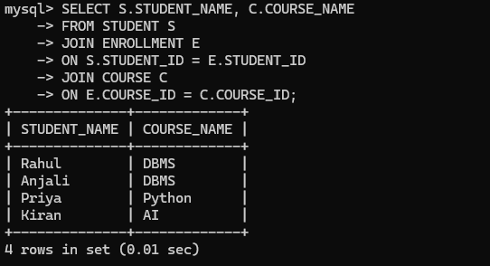

Approach 2: Using Subquery

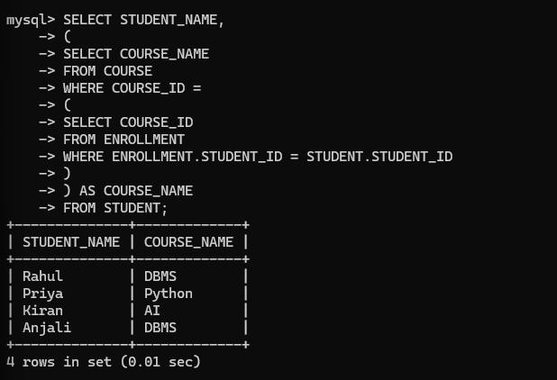

2 . Display Students Scoring Above 80

Approach 1: Using JOIN

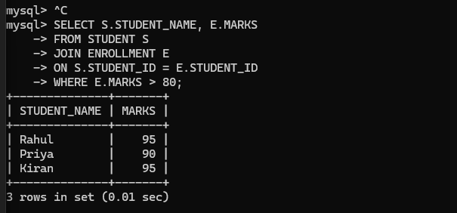

Approach 2: Using Subquery

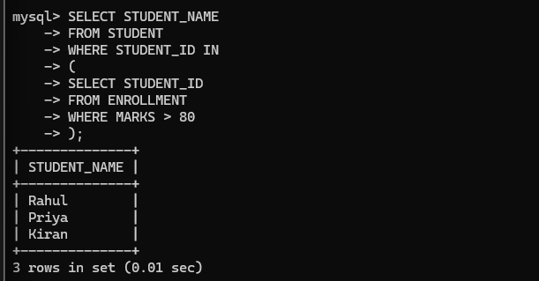

3 . Display Students Enrolled in DBMS

Approach 1: Using JOIN

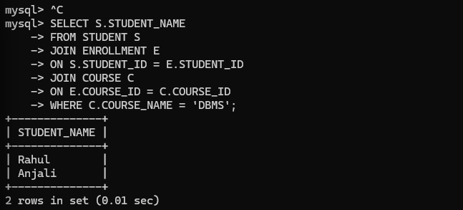

Approach 2: Using Subquery
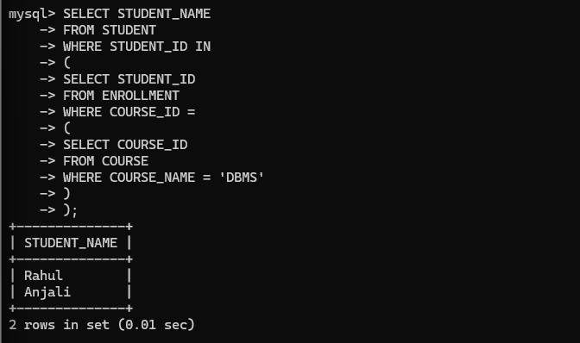

Comparison Table

Feature | JOIN | Subquery
Performance | Faster for large data | Usually slower
Readability | Easy for related tables | Easier for simple conditions
Multiple Tables | Excellent | Can become complex
Execution Speed | High | Lower than JOIN
Preferred For | Combining related tables | Filtering based on another query

Evaluation
- JOIN is generally more efficient because it retrieves data by combining tables in a single operation.
- Subqueries are useful when one query depends on the result of another, but they may be slower for large datasets.
- For most database applications involving multiple tables, JOINs are the preferred approach.

- Design and Implement Views for Restricted Data Access

Aim
To create SQL views for a database system to provide restricted data access and understand their use for security and abstraction.
View 1: Student Details View

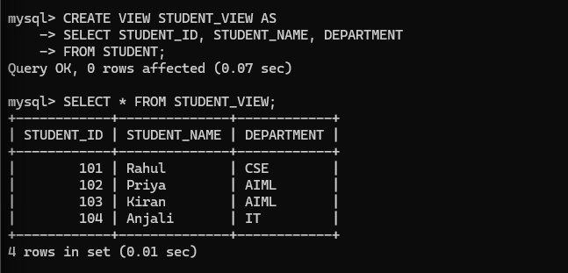

View 2: Student Course View
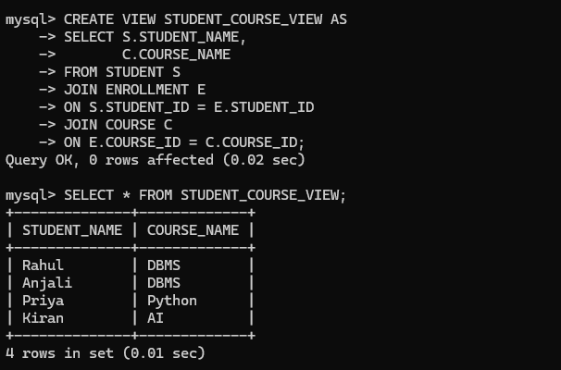

View 3: High Marks View

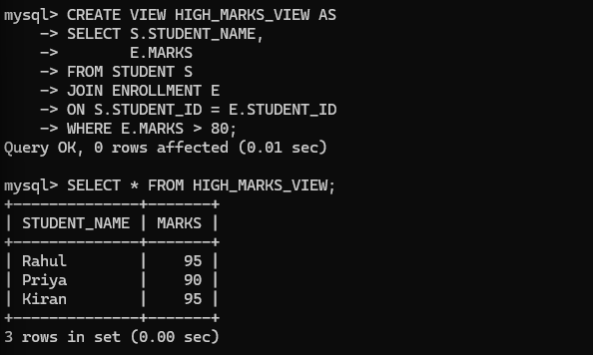

View 4: Faculty Course View

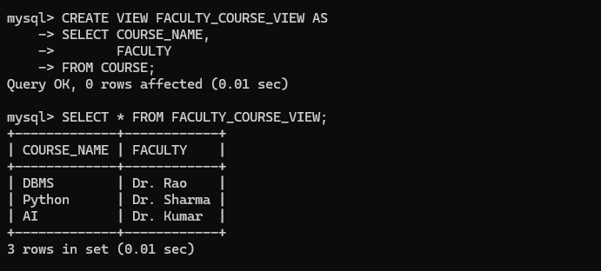

- Given a Database Schema, Write Relational Algebra Expressions and Convert Them into Equivalent SQL Queries

Aim
To write relational algebra expressions, convert them into equivalent SQL queries, and analyze the differences in representation.
1 . Display all student names
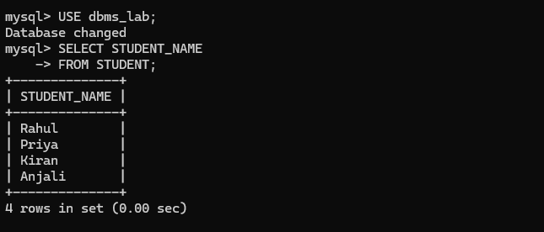

Difference
- Relational Algebra: Uses the projection operator (π).
- SQL: Uses the SELECT statement.

2 . Display students from the CSE department
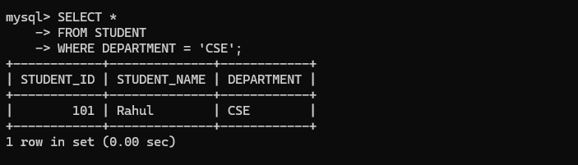

Difference
- Relational Algebra: Uses the selection operator (σ).
- SQL: Uses the WHERE clause.

3 . Display student names and course names



Difference
- Relational Algebra: Uses the join operator (⋈).
- SQL: Uses the JOIN keyword with ON.

4 . Display students scoring above 80 marks


Difference
- Relational Algebra: Applies Selection (σ) after the join.
- SQL: Uses the WHERE clause after JOIN.

5 . Display students enrolled in the DBMS course
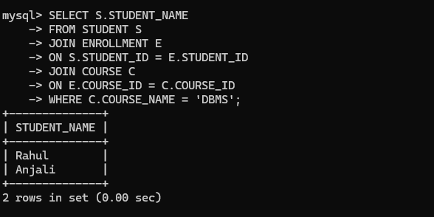

Difference
- Relational Algebra: Multiple conditions are written inside the selection operator.
- SQL: Multiple conditions are written in the WHERE clause using AND.

Comparison Table

Relational Algebra | SQL
Procedural query language | Declarative query language
Uses mathematical operators (σ, π, ⋈) | Uses SQL keywords (SELECT, FROM, WHERE, JOIN)
Describes sequence of operations | Describes the required result
Mainly used for query design and theory | Used for practical database implementation

- Optimize Inefficient SQL Queries

Aim
To optimize inefficient SQL queries using JOINs, Indexes, and Views, and evaluate their performance improvements.
Problem 1: Display Student Name and Course Name
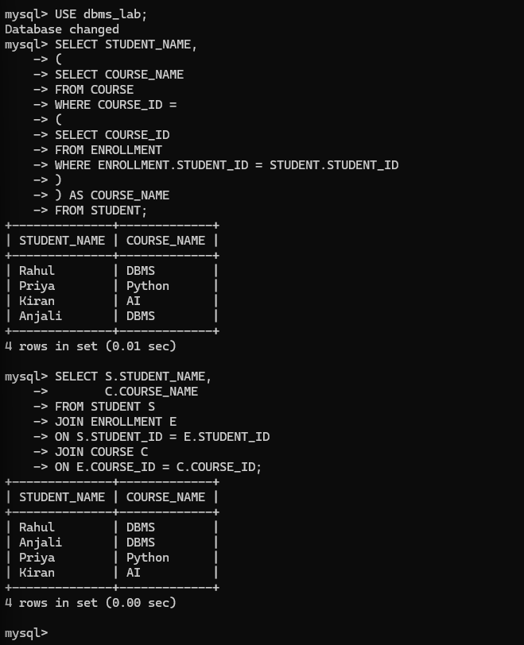

Performance Improvement
- JOIN executes faster.
- Avoids repeated execution of subqueries.
- Better for large databases.

Problem 2: Display Students with Marks Above 80
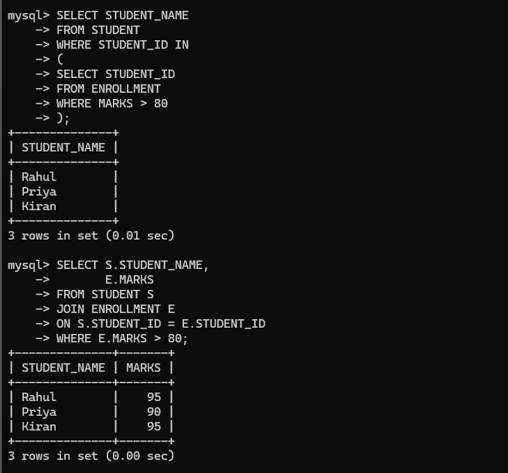

Performance Improvement
- JOIN retrieves data in a single operation.
- Faster execution.
- Easier to read and maintain.
Problem 3: Create an Index

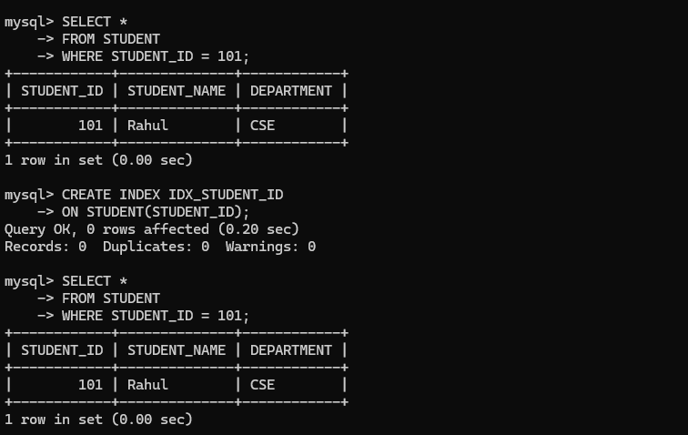

Performance Improvement
- Faster searching.
- Reduced data scanning.
- Efficient retrieval for large tables.

Problem 4: Use a View
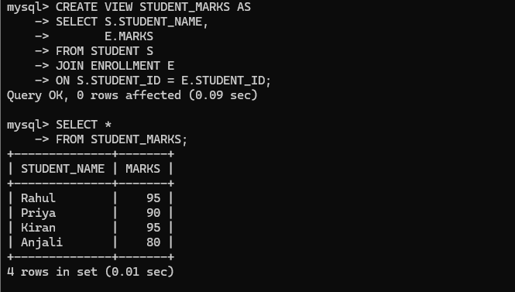

Performance Improvement
- Simplifies complex queries.
- Improves readability.
- Provides data abstraction.

Comparison Table

Technique | Before Optimization | After Optimization
Subquery | Multiple nested queries | JOIN
Search | Full table scan | Index
Complex Query | Long SQL statements | View
Execution Speed | Slower | Faster
Readability | Moderate | Better

- Develop a Complex SQL Query Involving Grouping, Aggregation, and Nested Queries

Aim
To develop complex SQL queries using GROUP BY, aggregate functions, and nested subqueries to solve real-world database problems.
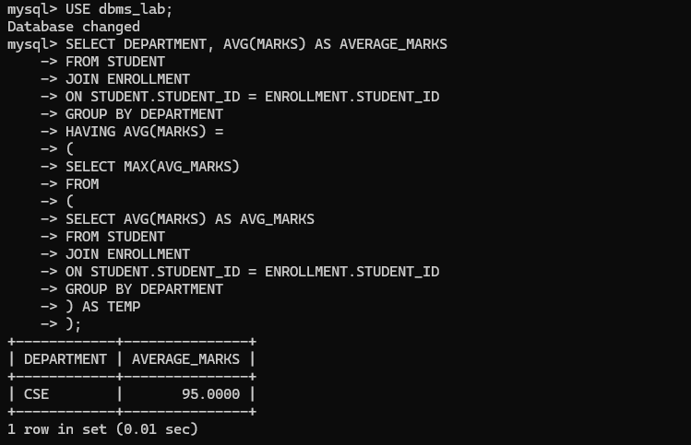
Problem 1: Find the department with the highest average marks

Problem 2: Display the course having the maximum number of students
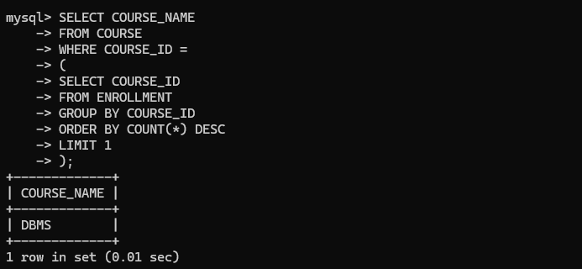

Problem 3: Display departments having more than one student

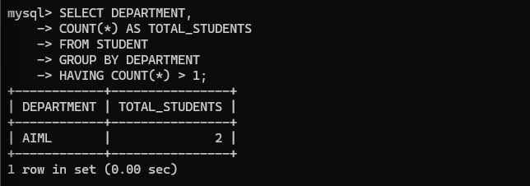

Problem 4: Display students whose marks are above the average marks
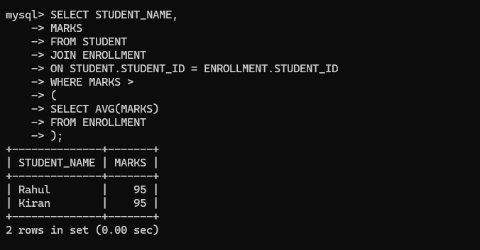

Problem 5: Display the faculty teaching the course with the highest average marks
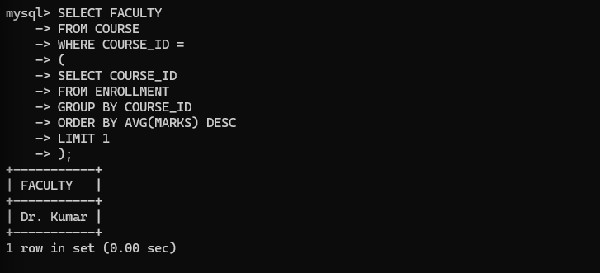

Comparison of SQL Features Used

SQL Feature | Purpose
GROUP BY | Groups rows based on a column
COUNT() | Counts records
AVG() | Calculates average
MAX() | Finds maximum value
HAVING | Filters grouped data
Nested Subquery | Uses the result of another query
ORDER BY | Sorts the result
LIMIT | Returns only the required rows

- Experiment: Analyze Query Requirements and Choose Views, Joins, or Subqueries

Aim
To analyze different query requirements and decide whether to use Views, Joins, or Subqueries, and justify the choice based on efficiency and usability.

Problem 1: Display Student Name and Course Name

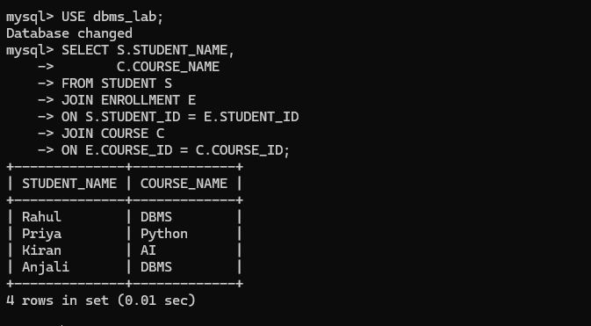

Reason
- Data comes from multiple related tables.
- JOIN is faster and more efficient.
- Easy to retrieve related records.
Problem 2: Display Students Scoring Above the Average Marks

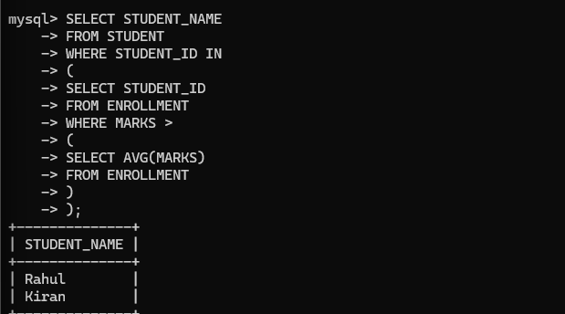

Reason
- The query depends on the result of another query (average marks).
- Subquery makes the logic simple and clear.

Problem 3: Display Student Name and Marks Frequently

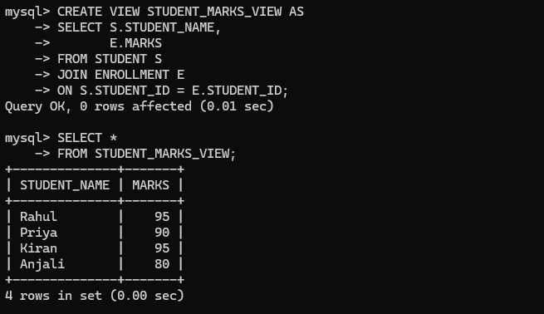

Reason
- Frequently used query.
- Simplifies repeated SQL statements.
- Provides security by exposing only required columns.
Problem 4: Display Students Enrolled in DBMS
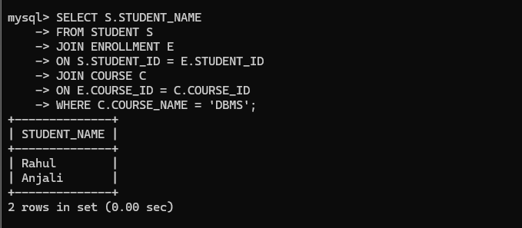

Reason
- Requires data from three related tables.
- JOIN provides better performance than nested queries.

Problem 5: Display the Highest Scoring Student(s)

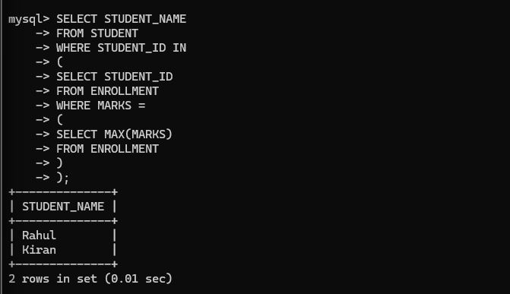

Reason
- The query first finds the maximum marks.
- Then retrieves the corresponding student names.
- Subquery is suitable because the outer query depends on the inner query result.

